|  |  |  |
| --- | --- | --- |
| **EX:2** | **EDA-Data Import and Export** | **AD23632** |

**Aim:**

• Importing data from CSV, Excel, SQL databases, and web scraping  
• Handling different data formats  
• Export a DataFrame to an Excel file

**CODE:**

import pandas as pd  
import sqlite3  
from google.colab import files

uploaded = files.upload()  
df\_csv = pd.read\_csv('final\_dataset.csv')    
print("✅ CSV Data:")  
print(df\_csv.head())

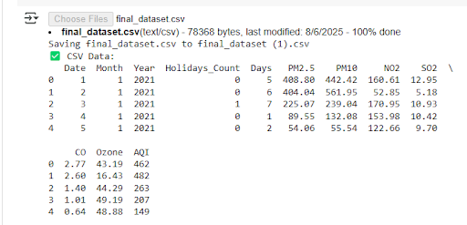

uploaded = files.upload()  
df\_excel = pd.read\_excel('converted\_file.xlsx')  
print("✅ Excel Data:")  
print(df\_excel.head())

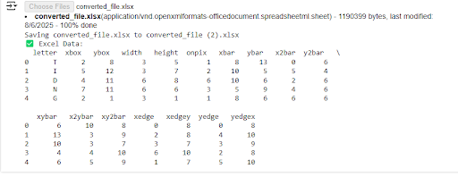  
  
conn = sqlite3.connect(':memory:')  
cursor = conn.cursor()  
  
cursor.execute("CREATE TABLE products (id INTEGER, name TEXT, price INTEGER)")  
cursor.executemany("INSERT INTO products VALUES (?, ?, ?)", [  
    (1, 'Laptop', 1000),  
    (2, 'Tablet', 600),  
    (3, 'Phone', 400)  
])   
  
conn.commit()  
  
df\_sql = pd.read\_sql\_query("SELECT \* FROM products", conn)  
print("✅ SQL Data:")  
print(df\_sql)

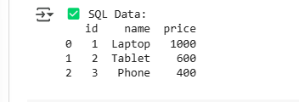

df\_web = pd.read\_html("[https://en.wikipedia.org/wiki/List\_of\_countries\_by\_GDP\_(nominal)](https://en.wikipedia.org/wiki/List_of_countries_by_GDP_%28nominal%29)")[2]  
print("✅ Web-Scraped Table:")  
print(df\_web.head())

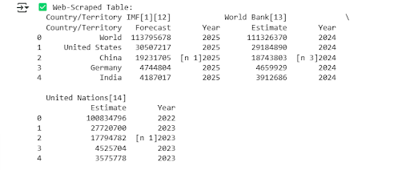

json\_data = '{"name": ["Alice", "Bob"], "age": [25, 30]}'  
df\_json = pd.read\_json(json\_data)  
print("✅ JSON Data:")  
print(df\_json)

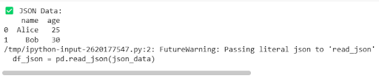  
data\_dict = {  
    'Fruit': ['Apple', 'Banana', 'Orange'],  
    'Quantity': [10, 15, 20]  
}  
df\_dict = pd.DataFrame(data\_dict)  
print("✅ Dictionary Data:")  
print(df\_dict)

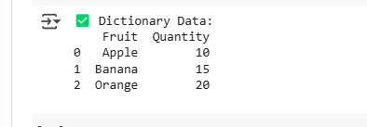  
  
df\_dict.to\_excel("exported\_file.xlsx", index=False)  
print("✅ DataFrame exported to Excel: exported\_file.xlsx")

C:\Users\AI_LAB\Pictures\Saved Pictures\7.png

**Result:**

Thus the EDA-Data Import and Export is done successfully.